ERC Consolidator Grant 2018

Research proposal [Part B2]

**Part B2: *The scientific proposal* (max. 15 pages, references do not count towards the page limits)**

**Q4D: Quasars in the 4th Dimension**

**Contents**

*All massive galaxies are thought to have supermassive black holes at their centres, and to have undergone a “quasar phase” in their past. Along with fusion in stars, accretion onto the central supermassive black hole is the main energy source available to a galaxy. However, we are missing a deep understanding of galaxy formation theory since we still do not understand in key detail how the energy associated with the quasar escapes the central engine to impact the host galaxy and the intergalactic medium. Further issues arise since recent observations of extreme variability in quasars have broken standard viscous accretion disk models.*

*In 4QD, we propose the ground breaking idea of combining the data from several next-generation state-of-the art surveys (SDSS-V, DESI, LSST, 4MOST, ESA Euclid and JWST) in order to go beyond the state- of-the-art and construct the extragalactic dataset with the crucial time-domain aspect that is necessary to address the current challenges. The experience of the PI ( add your name here, it is the first time you refer to yourself) along with the strategic data nexus aspect of the Royal Observatory at the University of Edinburgh makes my group uniquely placed to address and answer this problem. The goal is to create a holistic theory of accretion disk physics and quasar feedback in galaxy formation theory. We are also extremely well placed to discover brand new extragalactic variable phenomena.*

# a. State-of-the-art and Objectives

The objectives for this proposal are: O1, to access and combine several new state-of-the-art large astronomical datasets; to kick start the new field of variable extragalactic astrophysics; to create a holistic theory of accretion disk physics and quasar feedback in galaxy formation theory, and to discover brand new astronomical phenomena. Details are given in Table 1. We stress that the novel and high-risk/high-gain combination of these new state-of-the-art large datasets will by design *go significantly beyond the state-of-the-art* and will allow substantial advances in the frontiers of understanding astrophysical phenomena as well as discovering new objects.

## a.1 Background

Quasars1 are powered by accretion of material onto supermassive black holes (SMBHs), via accretion disks. In the local Universe, there is a link between the key properties of massive galaxies, such as bulge mass, and their central supermassive black holes (e.g., McLure and Dunlop, 2002; Häring and Rix, 2004; Salviander et al., 2007; Greene et al., 2010; Kormendy and Ho, 2013). This has led to the proposal that the supermassive

1. Historically, “quasars” and “Active Galactic Nuclei (AGN)” have described different luminosity/classes of objects, but here we use these terms interchangeably (with a preference for quasar) in recognition of the fact that they both describe accreting supermassive black holes (e.g. Haardt et al., 2016).

black hole, when accreting, has an influence on its host galaxy by the means of some regulatory “feedback” mechanism(s) (e.g., Sijacki et al., 2007; Hopkins et al., 2008; Alexander and Hickox, 2012; Fabian, 2012; King and Pounds, 2015). However, the details of the physical processes involved in this ‘AGN/quasar feedback’ are still disputed and, moreover, direct observational evidence for quasar feedback in the early universe is conspicuous by its absence (e.g., Heckman and Best, 2014; Naab and Ostriker, 2017). Hence, a major source of uncertainty in our current understanding of galaxy evolution is how supermassive black holes influence, and potentially regulate, their host galaxies (Vogelsberger et al., 2013, 2014; Schaye et al., 2015; Anglés-Alcázar et al., 2013, 2017).

What is the main quasar triggering mechanism at the height of quasar activity? What direct observational evidence in individual objects links quasar activity to star formation? Can we observe “quasar feedback” in action, in situ, for the most luminous sources? Such unknowns about the co-evolution of black holes and their host galaxies remain among the most fundamental unanswered questions in extragalactic astronomy.

Furthermore, the details of the physical processes involved in the quasar activity including how the SMBH directly couples and affects its most local environment, i.e., the accretion disk, broad line region and dusty torus, are still unknown at this point (e.g., Netzer, 2015; Padovani et al., 2017).

Although it has long been established that quasars are powered by accretion discs surrounding supermassive black holes, there have also been long-standing issues. For example, the observed spectral energy distributions (SEDs) of typical quasars (e.g., Koratkar and Blaes, 1999; Sirko and Goodman, 2003) differ markedly from classical predictions (Shakura and Sunyaev, 1973; Pringle, 1981) with a typical observed quasar SED flat in *λ Fλ* over several decades in wavelength (Elvis et al., 1994; Richards et al., 2006). Also, real accretion disks seem to be cooler (e.g., Lawrence, 2012) and larger (e.g., Pooley et al., 2007; Morgan et al., 2010, 2012; Mosquera and Kochanek, 2011) than the standard accretion disk model predictions.

However, even more troubling are new observations of *extreme variability* in some objects (see next section) - factors of several over a decade or so, including, crucially, at optical wavelengths, and not just in the extreme UV or in X-rays. This has led to the “Quasar Viscosity Crisis” (Lawrence, 2018).

**As such, we are left in the embarrassing current situation of invoking galaxy-wide “quasar feedback” in order to reconcile demographic observations in cosmological-scale simulations, but where we currently do not understand the physics of mechanism that is supposed to initiate this necessary and vital energy transport.**

### Observational State-of-the-Art

Here we present a concise overview of the observational state-of-the-art in the brand new field of variable extragalactic astrophysics, concentrating on quasar studies.

**A MICROSCOPE FOR RAPID CENTRAL ENGINES:** “Changing-look” quasars (CLQs; LaMassa et al., 2015; Runnoe et al., 2016; Ruan et al., 2016; Runco et al., 2016; MacLeod et al., 2016; Yang et al., 2017) are de- fined to be luminous quasars which have a dramatic appearance, or disappearance, of their broad emission-line component on observed-frame month-to-year timescales. CLQs are important since they offer a direct observational probe into the physical processes dictating the structure of the broad-line region (BLR). These timescales can potentially be associated with the viscous timescale (the drift time through the accretion disk), the light crossing timescale (critical for reverberation mapping and disk reprocessing) and the dynamical timescale of the BLR. *CLQs are thus an ideal laboratory for studying accretion physics, as the entire system responds to a large change in ionizing flux on a human timescale.*

In MacLeod *et al*. (2016) I co-led the first systematic search for CLQs based on photometry from SDSS and Pan-STARRS1, along with repeat spectra from the SDSS/BOSS, and reported the discovery of 10 CLQs.

This is a startling result since we now estimate *≈*10-15% of bona fide quasars may exhibit ‘changing look’ behaviour on *∼*10 year (rest-frame) timescales. However, plausible time-scales for variable dust extinction are factors of 2 *−* 10 too long to explain the dimming and brightening in these sources. Changes in accretion rate

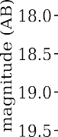are the currently favored explanation for CLQs, but then the question of how the inner accretion disk couples to the BLR immediately arises. Further investigation is thus warranted.

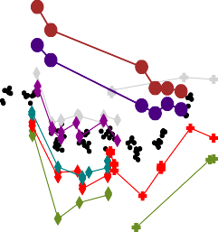

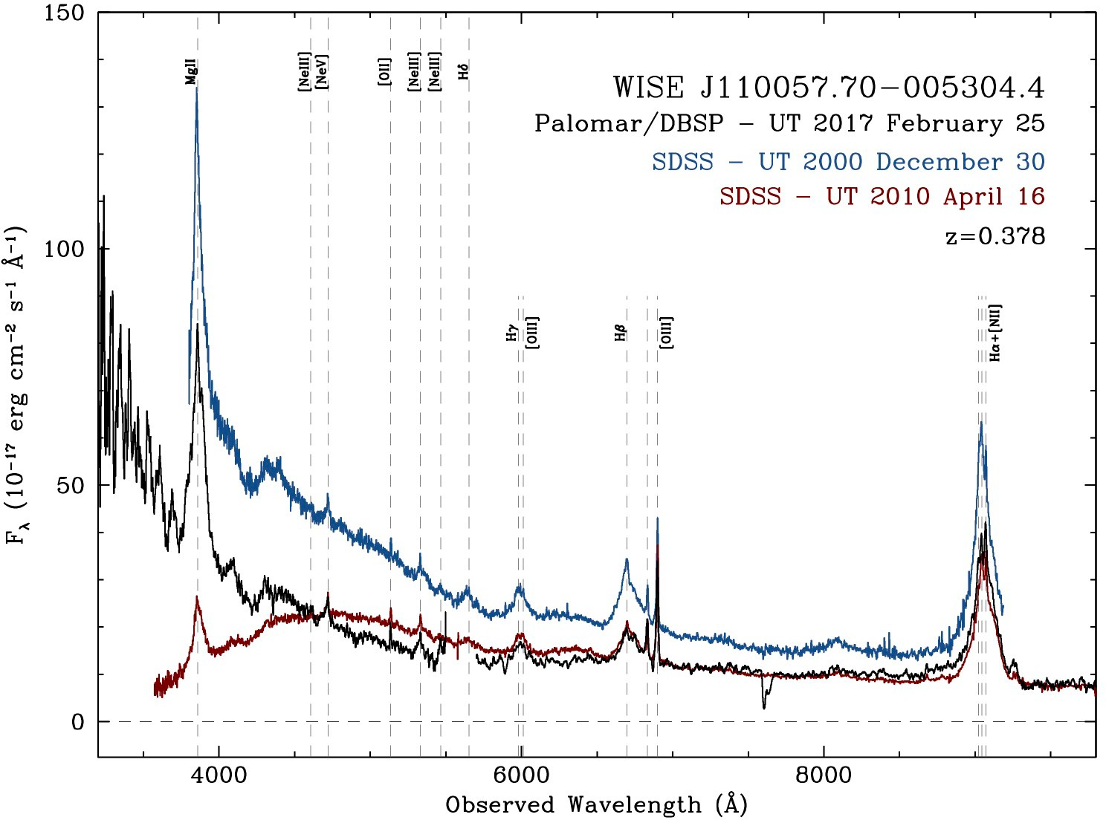

|  |  |  |  |
| --- | --- | --- | --- |
|  |  |  |  |

Figure 1: *(Left:)* The optical and infrared light-curve for J1100-0053; Note the fall in the infrared, whereas there is a decrease, but then recovery in the optical. *(Right:)* Three epochs of spectra for J1100-0053. The spectacular downturn in the blue for the 2010 spectrum indicates a dramatic change in the accretion disk.

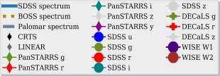**NEW IR INVESTIGATIONS INTO THE CLQ POPULATION:** Taking advantage of new optical imaging data from the Dark Energy Camera Legacy Survey [(DECaLS)](http://legacysurvey.org/decamls/) and new IR light-curves from NEOWISE (Meisner et al., 2017b,a), I have made further in-roads into understanding the CLQ population. This includes identifying objects with rapidly changing IR light-curves and also accretion disk changes, e.g. the *z* = 0*.*378 quasar SDSS J110057-005304.4, see Figure 1. From J1100-0053, my new model (Ross et al., 2018) suggests a dramatic new picture of the physics of the CLQs governed by processes at the innermost stable circular orbit (ISCO) and the structure of the innermost disk. Expanding these new observations in sample and temporal size, in order to properly inform our theoretical models is the next big challenge.



**In summary, as of the time of writing, the observational state-of-the-art for extreme variable quasars is 44 objects, 11 of which I have either discovered or co-led the discovery.**

### Theoretical State-of-the-Art

Here we present a concise high-level overview of the theoretical state-of-the-art and in particular focus on issues related to our quasar studies.

**CONTEMPORARY ACCRETION DISK THEORY:** The accretion disk scale is ;:, 103 106 r*g*, which is 5 10*−*3 to 5 pc for a 108 MBH. Yuan and Narayan (2014) review, black hole accretion flows can be divided into two

*− ≈ ×*

broad classes: cold and hot. Cold accretion flows consist of cool optically thick gas and are found at relatively high mass accretion rates. Hot accretion flows, are virially hot and optically thin, and occur at lower mass accretion rates. How a accretion disk flow transitions between ‘cold’ and ‘hot’, e.g. as the mass flowrate *m*˙ changes, is not well understood, and is an area of current activity.

**CONTEMPORARY GALAXY FORMATION THEORY:** Contemporary cosmological magnetohydrodynamical galaxy formation simulations take into account a wide range of physical processes, use state-of-the-art numer- ical codes and take weeks to months to run on the largest supercomputers. They are incredibily sophisticated apparatus and allow us to gain deep insight into the physical processes that drive galaxy formation, including the energy connected to an accreting central SMBH. Naab and Ostriker (2017) present an up to date reivew of the major challenges for galaxy formation theory.

Current state-of-the-art cosmological simulations, for example, the EAGLE Project (Schaye et al., 2015; Crain et al., 2015) and the IllustrisTNG Project (Pillepich et al., 2018) employ and track 10s of billions resolution

elements across 100s of megaparsec-cubed volumes. For EAGLE (e.g. their L100N1504 simulation), the

fundamental units of dimensions mass (M), length (L) and time (T, i.e. resolution) are *∼* 2 *×* 105 for initial baryonic particle mass, “softening lengths” of 0.35-0.7 pkpc; and and time-steps sampling *∼*1000 years (*∼*106 time-steps across the age of the Universe)2. For the new IllustrisTNG “TNG100” model one has 1*.*4 *×* 106 for baryonic particle mass, softening lengths 0.2-1 pkpc, and 8 105*h−*1 M*0* for the seed black hole mass. As such, these are extremely powerful for global galactic properties, but these simulations cannot, and were never

*≈ ×*

designed to, explicitly address inner central engine physics.

Further progress is made with the new high-resolution “zoom-in” galaxy simulations, e.g. Feedback In Re- alistic Environments (FIRE-2; Wetzel et al., 2016; Hopkins et al., 2017) or MUFASA (Davé et al., 2016). In FIRE-2 for example, Wetzel et al. (2016) run a cosmological scale dark-matter-only simulation to redshift *z* = 0. An isolated DM halo is then selected, the particles are traced back to very high, *z* = 100 redshift and the ‘convex hull’ is regenerated at high resolution (embedded within the full lower-resolution volume). The fidu-

cial baryonic simulation contains dark matter, gas, and stars within the zoom-in region, comprising 140 million total particles, with *M*DM = 3*.*5 104*M0* and *M*gas*,*initial = 7070*M0*. The dark matter and stars have fixed grav- itational softening lengths of 20pc and 4pc, respectively. In these zoom-ins, the shortest time step achieved

*×*

is 180 years. As such, these ‘zoom-in’ simulations are impressive, but still not close enough to resolving the scales, masses and cadences needed in order to successful model e.g. the “changing look” quasars.

However, what is remains very concerning is that even once the mass, length and timescales are computation- ally accessible, *we currently do not know what physical prescriptions should be directed for the central black hole and quasar engines to follow.*

For example and as described in detailed in Weinberger et al. (2017), modelling AGNs in cosmological simula- tions poses several fundamental challenges. The detailed physical mechanisms of both accretion on to SMBHs, and the AGN-gas interaction are poorly understood (Hopkins and Quataert, 2010, 2011; Huarte-Espinosa et al., 2011; Gaibler et al., 2012; Anglés-Alcázar et al., 2013; Gaspari et al., 2013; Cielo et al., 2014; Costa et al., 2014; Anglés-Alcázar et al., 2015; Emsellem et al., 2015; Curtis and Sijacki, 2015, 2016a,b; Rosas-Guevara et al., 2015; Roos et al., 2015; Hopkins et al., 2016; Bieri et al., 2017; Anglés-Alcázar et al., 2017). This makes it at present impossible to formulate a ‘correct’ treatment for simulations. The long-time standard physical mechanism of Bondi-Hoyle-Lyttleton accretion, i.e. that of spherical accretion onto a compact object traveling through the interstellar medium (Hoyle and Lyttleton, 1939; Bondi and Hoyle, 1944; Bondi, 1952)

with the accretion rate given by *M*˙Bondi = *πG*2*M*2 *ρ/c*3, *is known to be a considerable oversimplification* (e.g.,

BH

*s*

Edgar, 2004). We need a new theory. And we need new observations to guide us here.

### Upcoming Surveys, Instruments and Missions

(Lawrence, 2016) emphasize that variability studies hold information on otherwise unresolvable regions in quasars. Likewise, population studies of large samples have been very productive for our understanding of quasars. These two themes are coming together in the idea of systematic variability studies of large samples and *over the next 5 or so years* the field of observational extragalactic astrophysics is poised for a fundamental and rapid change.

Starting in late 2019, a fleet of new telescopes, instruments and missions are coming online over the next few years that will leap-frog the quality and quantity of data we have available today. Over the course of the next 5-6 years, surveys and missions including the fifth incarnation of the Sloan Digital Sky Survey (SDSS-V3), the Large Synoptic Survey Telescope (LSST4), the Dark Energy Spectroscopic Instrument (DESI5) survey, the 4-meter Multi-Object Spectroscopic Telescope (4MOST6) survey, and the ESA *Euclid* mission7, will see first light. Even more imminent is the launch of the *James Webb Space Telescope* (JWST8).

1. The times are spaced logarithmically in the expansion factor *a* such that ∆*a* = 0*.*005*a*. 3 [www.sdss.org/future/](http://www.sdss.org/future/) 4 lsst.org

5 desi.lbl.gov 6 4most.eu 7 sci.esa.int/euclid/ 8 jwst.stsci.edu

Overview of Facilities and Surveys related to this proposal

**IMMINENT:**

The **Sloan Digital Sky Survey (SDSS):** An ongoing project, currently in its fourth phase, SDSS-IV. ThePI. was a leading member of the SDSS-III: Baryon Oscillation Spectroscopic Survey (BOSS). The fifth generation of Sloan Digital Sky Surveys, SDSS-V will be an all-sky, multi-epoch spectroscopic survey, yielding spectra of over 6 million objects during its lifetime. In particular, the SDSS-V Black Hole Mapper (BHM) will focus on long-term, time-domain studies of AGN, including direct measurement of black hole masses and changing-look quasars, and on the optical characterization of eROSITA X-ray sources. Data taking is due to start in 2020. Access would be through a e184,100 ‘buy-in’, which allows access for the P.I. and one PDRA. *Data Products: Repeat spectra in the North and Southern Hemisphere for 500,000 bright QSOs.*

The **Dark Energy Spectroscopic Instrument (DESI) Survey:** is a 5 year cosmology survey that will be conducted on the Mayall 4-meter telescope at Kitt Peak National Observatory starting in 2019. It uses the 5,000 fiber Dark Energy Spectroscopic Instrument and will obtain optical spectra for 20 million galaxies and quasars. The P.I. helped write the original science case and proposal for DESI, but having left the U.S./LBNL, he has no longer data access rights. The DESI Survey starts in late 2019 and data access is through a e200,100 ‘buy-in’, which allows access for the P.I. and two PDRAs. *Data Products: Spectra of 1e6 quasars across 14,000 deg*2 *of the Northern Sky.*

*≈*

The **Large Synoptic Survey Telescope (LSST)** project will conduct a 10-year survey of the sky, imaging the full Southern Sky every 3 nights. The LSST survey is designed to address four science areas (Understanding the Mysterious Dark Matter and Dark Energy; Hazardous Asteroids and the Remote Solar System; The Transient Optical Sky; The Formation and Structure of the Milky Way) and is an absolutely unique facility as far as areal, temporal and wavelength coverage. The U.K. is a member of LSST. *Data Products: ugrizY broadband optical and near-infrared imaging for 20,000 deg*2*. Images the full Southern Sky every 3 days.*

***Euclid*** is an ESA Medium Class mission to map the geometry of the dark Universe. It aims to under- stand why the expansion of the Universe is accelerating and what the nature of the source responsible for this acceleration (“dark energy”) is. The mission will investigate the distance-redshift relationship and the evolution of cosmic structures by measuring shapes and redshifts of galaxies and clusters of galaxies out to redshifts 2, or equivalently to a look-back time of 10 billion years. *Euclid* will also discover a range of near-infrared (NIR) detected quasars, *Euclid* is planned for launch in mid-2021. *Data Products: Very broadband optical and 3 filter near-infrared space-based imaging for 15,000 deg*2*.*

*∼*

The **4-metre Multi-Object Spectroscopic Telescope (4MOST):** is a fibre-fed spectroscopic survey facility on the VISTA telescope with a large enough field-of-view to survey a large fraction of the southern sky. The facility will be able to simultaneously obtain spectra of 2,400 objects distributed over a field-of-view of 4 square degrees. The initial Galactic and Extragalactic surveys will operate over a five-year period delivering spectra for 25 million objects over ;215,000 deg. 4MOST will commence science operations in early 2022. *Data Products:* 5MOST will operate continuously for an initial

*≥*

five-year public survey delivering spectra for *≥*25 million object over 15,000 deg2.

The **James Webb Space Telescope (JWST)** is a space telescope developed in coordination among NASA, the European Space Agency, and the Canadian Space Agency. It is scheduled to be launched in June 2019. The telescope will offer unprecedented resolution and sensitivity from 0.6 to 27*µ*m. JWST is

a partnership between NASA, ESA and the Canadian Space Agency. In particular, ESA’s contributions to JWST include (but are not limited to) the NIRSpec instrument and the Optical Bench Assembly of the MIRI instrument. In return for these contributions, ESA gains full partnership in JWST and secures full access to the JWST observatory for astronomers from ESA Member States on identical terms to those of today on the *Hubble Space Telescope*. *Data Products: Revolutionary optical to mid-infrared deep-field imaging and spectra. Unique access to wavelengths λ >* 2*µm, inaccessible from the ground, ideal for high-z quasar studies.*

The **Extended Roentgen Survey with an Imaging Telescope Array (eROSITA)** is the main in- strument on the Spektr-RG mission, an international high-energy astrophysics observatory. Set to launch in 2019 with both high sensitivity and a large FOV, eROSITA will discover as many new X-ray sources in its first twelve months as are known today, after more than 50 years of X-ray astronomy. SDSS-V will provide optical spectroscopic measurements including identifications and redshifts, of 400,000 eROSITA X-ray sources detected in the first 1.5 years of the all sky survey. In addition, SDSS-V’s BHM will characterize numerous serendipitous discoveries, extreme and rare objects, transients, and other peculiar variables found in the eROSITA survey (Merloni et al., 2012), and expand an optical+X-ray quasar sample with implications for observational cosmological constraints (e.g. Risaliti and Lusso, 2015).

*∼*

Notes: 4MOST has full access to the full LSST footprint. LSST will overlap half (7,500 deg2) of the

*Euclid* footprint.

**ONGOING:**

The **Wide-field Infrared Survey Explorer (WISE)** is a NASA infrared-wavelength astronomical space telescope launched in December 2009 and is still operation (in its “NEOWISE-R” mission phase as at the time of writing). WISE performed an all-sky astronomical survey with images at 3.4, 4.6, 12 and 22*µ*m using a 40cm (16 in) diameter infrared telescope in Earth orbit.

The **ESA** *Gaia* mission is an ongoing mission to chart a three-dimensional map of our Galaxy, the Milky Way, in the process revealing the composition, formation and evolution of the Galaxy. Gaia is pro- viding unprecedented positional and radial velocity measurements with the accuracies needed to produce a stereoscopic and kinematic census of about one billion stars in our Galaxy and throughout the Local Group. This amounts to about 1 per cent of the Galactic stellar population.

*∼*

*The timing for this proposal could not be better or more imperative.* The first of the data “firehoses” turns on in late 2019, with the full datastream from our key sources fully online around 2022. As such, with two years to use existing datasets as testbeds, we have the time to ramp-up our efforts, while also being able to take advantage of the initial data releases of all these new projects.

## Objectives

The outstanding issues and novel investigations that are pertinent to this proposal are summarised in the Table below.

Our ERC Consolidator grant proposal will radically improve our understanding of one of the two fundamental energy sources available to galaxies; that of accretion onto the compact object in the central engine. We will achieve this by leveraging several of the new, large-scale surveys that are coming online in the next few years. The scope and remit of an ERC Consolidator grant will allow us to combine these data products in a manner that will not only establish the new state-of-the-art in extragalactic variable science, *it will establish*

*and kickstart the new field of extragalactic variable science itself*. The P.I. is a world-leader in observational quasar astrophysics, both in terms of survey work and individual object study. Our proposal takes astrophysics into the 2020s, going from single objects samples, to surveys and samples of millions of objects leveraging these multi-billion Euro/dollar/pound next generation missions, telescopes and their subsequent datasets.

**Outstanding Issues in Variable Extragalactic Astrophysics**

Key Objective Investigation and Resolution

THE PHYSICS OF ACCRETION

Investigate “hot” and “cold” mode accretion in the quasar population; determine the rates and timescales, and characterising the Changing Look Quasar (CLQ) population.

Probe and determine the physical state of the inner parsec of the quasar central engine

Identify and characterize all the CLQs in DESI, SDSS-V, 4MOST and LSST.

Rapid analysis and response for LSST quasar light curves. Detailed accretion disk theoretical model- ing.

OBSCURED ACCRETION AND GALAXY FORMATION

Establish the relative importance of major mergers, minor mergers, cold streams and secular evolution have towards the growth of SMBHs across cosmic time.

Establish the bolometric output and origin of IR emission, and determine presence of extreme out-

Deep imaging data from LSST combined with searching for post-starburst signatures in DESI, SDSS-V, 4MOST spectra. Also NIRcam and MIRI imaging from JWST.

NIRSpec and MIRI MRS spectroscopy with JWST.

flows in the *z ∼* 2 *−* 3 quasar population.

Establishing the range of SED parameter space the

quasars occupy by a multi-wavelength multi-epoch “truth table dataset”

Discover the physical conditions under which SMBH grew at the epoch when most of the accre- tion and star formation in the Universe occurred

Build “The Quasar SED Rosetta Stone” using X-

ray, UV/optical, IR data as well as repeat optical observations from LSST.

Perform a complete census of AGN across *z* 0 7, focussing on *z* = 1 4 using medium-deep multi- wavelength datasets

*−*

*∼ −*

(*z ∼* 1 *−* 4)

GALAXY-SCALE FEEDBACK

Establish the theoretical impact of extreme out- Next-generation Hydro-simulation modelling.

flows in the *z ∼* 2 *−* 3 quasar population

Understand how the accretion disks around black

holes launch winds and outflows and determine how much energy these carry. Quantify the amount of “Maintenance/Jet/Kinetic” mode and “Transi- tion/Radiative/Wind” mode feedback.

Connect accretion disk theory and models to

cosmolgocial-scale hydro simulations for a holistic theory of “quasar feedback”.

**MAXIMISING SCIENCE RETURNS FROM EUROPEAN PRIORITIES:** Contemporary astronomy is a multi- national endeavor with many leading facilities being international collaborations. Although a project, with similar but much less ambitious science goals and return could be envisaged at the national level, the full discovery and break-through nature being described herein only comes to the fore when the data from the various international collaborations are combined intelligently. Critically data from leading European Southern Observatory (ESO) and European Space Agency (ESA) facilites will play a pivotal role here.

***LSST DESI***

***SDSS-V***

**WP2**

* + 1. **Quasar Catalogue Generation**
    2. **Quasar**

**WP1**

**QuasarSieve**

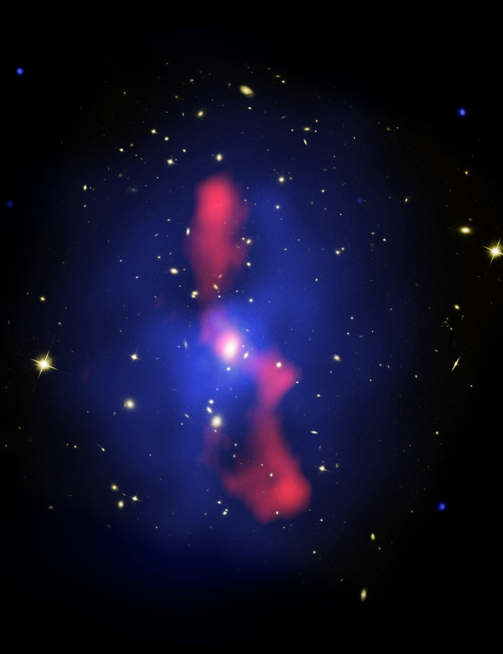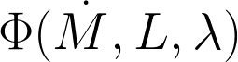

**WP3**

**Light Curve and Spectral analyses**

**PDRA1, NPR**

**WP6**

**New Object Discovery**

***4MOST***

***Euclid***

**Demographic Studies**

**PDRA1(*), PDRA2, PhD1, NPR**

**WP5**

**PDRA2(*), PDRA1, PhD1, NPR**

**WP4a**

**Accretion**

**PDRA1, PDRA2, PhD1, NPR**

**WP4b**

**Next generation hydro- dynamics**

**Key:**

***JWST studies***

***NPR***

**Disk**

**Simulations**

**PDRA3, NPR, (*WKMR)***

**PDRA3, NPR, (*RSD)***

***Data Source***

***medium risk***

***medium-to-high risk***

***high risk***

**WP4**

**Subparsec-to-Megaparsec Holistic Theory of Quasars**

**PDRA3, NPR**

Figure 2: An overview of our WPs. Arrows give general data or workflow, though natural iteration is expect, accounted and not necessarily shown. Φ indicative of giving quasar space density, see e.g., Ross et al. (2013). *Si, j* indicative of a model for the time variability of quasars as a stochastic process described by the exponential

covariance matrix (see e.g., MacLeod et al., 2010).

# Methodology

This ERC Consolidator proposal kick starts the new field of Variable Extragalactic Astrophysics. Due to the Data Science aspect of this proposal, it is, at its heart interdisciplinary. We present a bold research vision that is designed to be addressed by a research group, and the environment, current research areas and telescope access at the Institute for Astronomy at the University of Edinburgh is ideal to carry out these investigations. The science questions we seek to address are well-posed, yet strike at the heart of major and still open extragalactic astrophysical questions: Do we have a full accounting for the accretion history in the Universe? How does the energy ‘escape’ from the central engine to the host galaxy? Are the modes of AGN “feedback” that regulate a galaxy the same that regulate the AGN itself? What are the star-formation properties of mid-infrared luminous quasars at the peak of quasar activity?

Before laying out our Workplans, we make a note of the ethos involved in this project.

## Project ethos

**DATA SCIENCE AND OBSERVATIONAL ASTROPHYSICS:** Data science is a new interdisciplinary field of scientific methods to extract knowledge or insights from data in various forms, either structured or unstructured. It employs techniques and theories drawn from many fields within the broad areas of mathematics, statistics, information science, and computer science, in particular from the subdomains of machine learning, classifica- tion, cluster analysis, data mining, databases, and visualization. *Modern day observational astrophysicists are in all but name data scientists, and as such, this proposal is inherently interdisciplinary.*

**BREAKING DOWN THE DATA SILOS:** The bottleneck to using advanced data analysis is not skill base or technology; it is simply access to the data. A data silo is a repository of fixed data that remains under the control of one department/collaboration and is isolated from the rest of the world, much like grain in a farm silo is closed off from outside elements. These silos are isolated islands of data, and they make it prohibitive to extract data and put it to other uses. In research environments, and *especially in contemporary observational astrophysics*, the data silos are open, but due to the lack of raw person-power, still remain uncombined. The combination of P.I. and host institute means we are uniquely positioned to break down these astro-data silos for massively significant science gain.

**TARGETING BIG DATA:** This ERC will develop and employ leadership-computing systems and infras- tructure to explore, prove, and improve a wide range of data science techniques: uncertainty quantication; statistics; machine learning; deep learning; databases; pattern recognition; image processing; graph analytics; data mining; real-time data analysis; amd complex and interactive workflows.

**ALGORITHMS:** Our algorithms and methodology are based on the latest machine-learning and data science techniques. Specifically we will use [Python](https://www.python.org/) as the CS-glue, [NumPy](http://www.numpy.org/) for high-speed numerical processing, [pandas](https://pandas.pydata.org/) for efficient data ingestion and [Matplotlib](https://matplotlib.org/) for data visualization. [Astropy Project](http://www.astropy.org/) is a community effort to develop a common core package for Astronomy in Python and foster an ecosystem of interoperable astronomy packages, and one the P.I. and his team fully use and support. [scikit-learn](http://ogrisel.github.io/scikit-learn.org/sklearn-tutorial/index.html) is a Python module integrating classic machine learning algorithms in the scientific Python world. It aims to provide simple and efficient solutions to learning problems, accessible to everybody and reusable in various contexts. Resources such as the [Python Data Science Handbook](https://github.com/jakevdp/PythonDataScienceHandbook) have full details. This includes the “extreme deconvolution” ‘XDQSO’ technique9.

**OPEN INNOVATION, OPEN SCIENCE, OPEN TO THE WORLD:** The P.I. is an exceptionally strong, long- time and vocal supporter of “Open Access”. All my codes, data10, papers and proposals can be found at github.com/d80b2t. Indeed, this proposal itself is now at that location. One of the major research outputs of this ERC will be computer code. As such, we are already working with the [https://www.software.ac.uk/](http://www.software.ac.uk/) which was founded to support the UK’s research software community. Our software well be developed using

9 [github.com/xdqso/xdqso](https://github.com/xdqso/xdqso) 10 Where I am not breaking current data access agreements

the FAIR ideology (Findable, Accessible, Interoperable, Reusable11) and will be delivered in a manner which is fully inline with “Open Innovation, Open Science, Open to the World”.

## Work Packages

Our proposal contains six work packages that fall into three broad and complementary categories: observa- tional studies of large numbers (millons) of objects; high-risk, very high-reward observational studies of a small number (10s) of objects; theoretical modeling investigations. Table 1 summarises our overall WP plan. Risks and mitigation strategies are present for each WP as are Key Deliverables.

We define three PDRAs, “PDRA1”, “PDRA 2”, “PDRA 3”, and one PhD student, “PhD1”. The skill set of PDRA1 would include development of the underlying tools and techniques necessary to extract meaning from large and/or complex data sets. The skill sets of PDRA2 would include expertise in time series analysis, primarily with optical data but potentially also in other wavebands. The skill set of PDRA3 would include experience with fluid mechanics modelling and/or large computer simulations. PhD1 would have a Masters or a strong 4-year undergraduate degree in Physics or Mathematics with evidence of research-level project work.

**WP1: BUILD QUASARSIEVE:**

Raw events come from LSST. The UK LSST Data Access Center (DAC, based here at the University of Edinburgh) ingests this datastream and re-emits a filtered stream. In order to utilize this filtered datastream for our science goals we will build a “Stage 2 filter”, which we name *QuasarSieve*. This second stage filter will identify the quasars, add context, perform outburst forecasting etc. Our light-curve algorithm will sit on top of *QuasarSieve* and will trigger other telescopes to get e.g. timely spectrum or infrared data.

We will veto stars using ESA Gaia, the data of which are hosted by the Wide-Field Astronomy Unit (WFAU) here at the Royal Observatory, Edinburgh.

The heavy-industry computing infrastructure is being supplied by the LSST DAC and our task will be to build software in a timely and robust manner. This is a novel enterprise and a rate-limiting step in our overal programme, with the associated high-risk. We mitigate this risk with the data science and machine learning experience from PDRA1 and the P.I. (NPR). We will also mitigate risk by taking advantage of the algorithm resources and LSST DAC staff, here at the Royal Observatory, Edinburgh. We thus classify **WP1 as medium- risk, high-reward. Key Deliverables:** An open-source, well-documented software package that can interact with and return data from the LSST Data Access Center.

**WP2: QUASAR CATALOGUE GENERATION AND DEMOGRAPHIC STUDIES:**

Building the quasar corpus and cataloguing the observational data will be a vital step in beginning to pursue our science goals. This catalogue will be the glue that binds the observational projects together and will have not only the data, but also the metadata to enable the other WPs. Following on from the quasar catalogue gen- eration, a key science output will be the study of the quasar demographics. Luminosity function, clustering and higher-order statistics will be made in order to precisely determine the census of quasars, their environments, their host galaxy preferences and their evolution. All these are vital observational tests for galaxy formation models and theory (see WP4 below). The goal of this WP is to construct a quasar catalogue and make key observational tests. Given the P.I.s experience at these specific tasks, plus the effort level of PDRA1, PDRA2 and PhD this WP is deemed medium-risk.

**WP2 is medium-risk, high-reward. Key Deliverables:** A science-enabling compendium that will be the state-of-the-art quasar dataset for the 2020s. A suite of new, beyond-the-state-of-the-art quasar demographic measurements which are the boundary conditions for theoretical models.

11 Wilkinson, MD, Sci Data. 2016 Mar 15;3:160018. doi: 10.1038/sdata.2016.18.

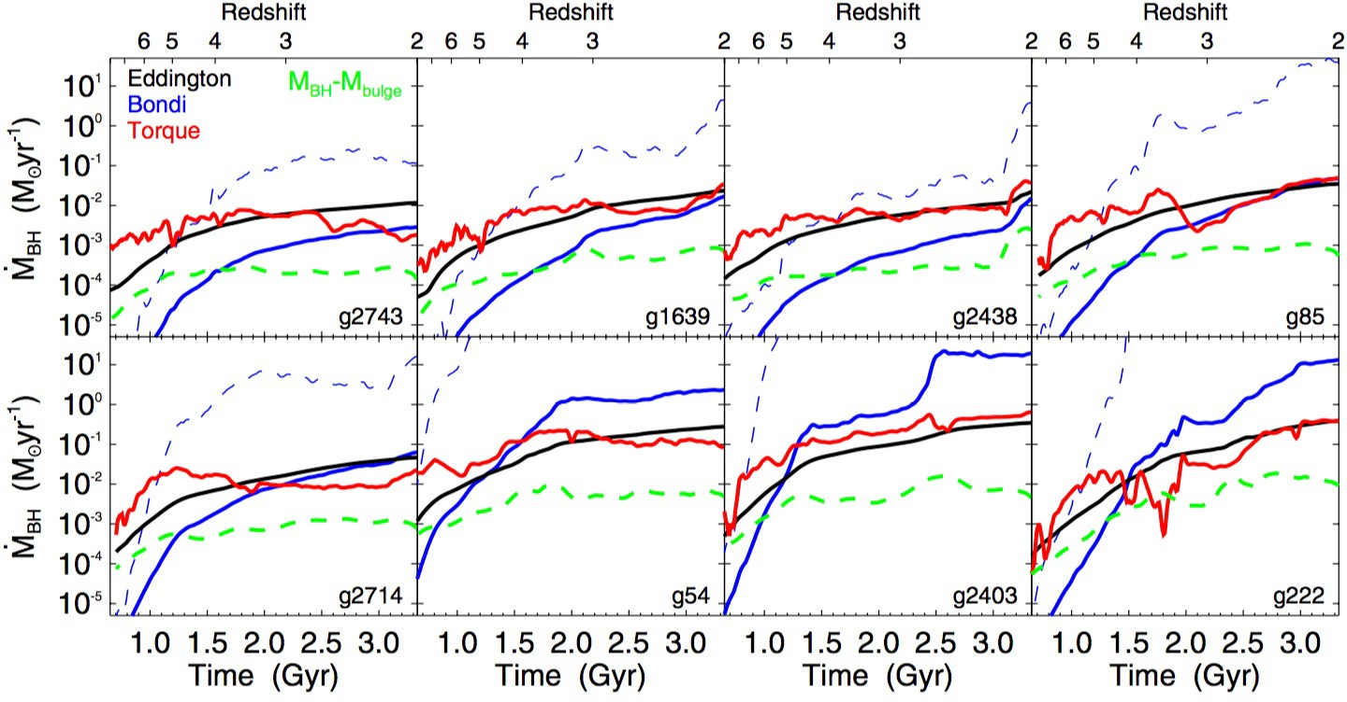

Figure 3: From Anglés-Alcázar et al. (2013): inferred accretion rates as a function of time for a black hole located at the center of each simulated galaxy. Black hole masses are taken from the *M*BH *M*bulge relation for the total stellar mass within the effective radius at all times, and accretion rates are calculated based on the properties of the host galaxy over time, according to (1) the Bondi-Hoyle-Lyttleton parameterization with the “boost-factor” *α* = 100 (solid blue line) and for the density-dependent *α* introduced by Booth and Schaye (2009, dashed blue line)), (2) the gravitational torque model of Hopkins and Quataert (2011, red line), and (3) the Eddington rate (black line). Dashed green lines correspond to the actual accretion rates required for black

*−*

holes to grow according to the *M*BH *− M*bulge relation for each galaxy at all times.

**WP3: LIGHT-CURVE AND SPECTRAL ANALYSES:**

Another major scientific output that will originate from the quasar corpus catalogue generation will be the full and detailed light-curve and spectral analyses of the said catalogue. This will result in the discovery of light-curve trends with quasar type, new methods to measure black hole mass and the key science goal to see which quasars are “changing-look” objects. This WP will have a data science/machine learning aspect. The goal of this WP is to elucidate the physical processes that drive quasar variability. The full Light-Curve and Spectral Analyses that we envisaged will be a significant amount of work, leading to significant high-reward science.

**WP3 is medium-risk, high-reward.** This level of investigation is highly novel, though we envisage no major barriers outside of our control to achieving our science goals and PDRA1, PDRA2, as well as the P.I. (NPR) and PhD1 effort will be directed towards this. As such, we deem this medium-risk. **Key Deliverables:** Mea- surements, for the first time of how the light-curves and spectra of quasars depend on key physical quasar properties e.g. *M*SMBH, luminosity, *λ* = log(*L/L*Edd), spin etc. These measurements will allow us to make direct comparisons to accretion disk models.

**WP4: ACCRETION DISK AND QUASAR FEEDBACK SIMULATIONS:**

New accretion models are needed to fully explain the observational data of “changing look” quasars that we have examples of today and the “Quasar Viscosity Crisis”. New radiation MHD codes begin to explain the ob- servations here, but further development is needed to gain the desired deep understanding. Cosmological-scale hydrodynamic simulations with stellar and quasar feedbasck are now also online. The exceedingly ambitious

goal of WP5 is to develop new holistic accretion disk-to-cosmological scale simulations that explain our ob- servational results and link them to “quasar feedback”. WP4 is thus high-risk due to its novel nature and algorithmic complexity. We also envisage ramp-up time to get our theoretical simulations to the level that will be required by our beyond-the-state-of-the-art dataset. However, we mitigate this risk first by noting this will be the lead WP and top priority for PDRA3. We further mitigate this risk by invoking collaboration with accretion disk theorist Prof. Ken Rice (WKMR; Chair of Computational Astrophysics at the IfA, University of Edinburgh) and Prof. Romeel Dave (RSD; Chair of Physics in the IfA, University of Edinburgh).

Thus PDRA3, NPR, potentially PDRA2, with guidance where nesceassy from WKMR and RSD would collab- orate on this WP. We thus classify **WP4 as medium-to-high risk, very high-reward. Key Deliverables:** New accretion disk models and theory that explain the light curve data of our beyond-the-state-of-the-art dataset. New galaxy evolution models, describing the hydrodynamics involved on galactic scales, but related to the quasar central engine.

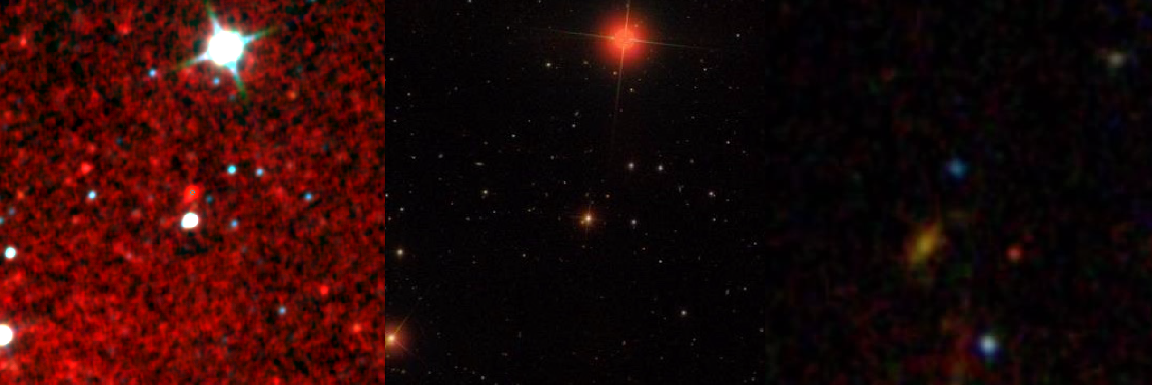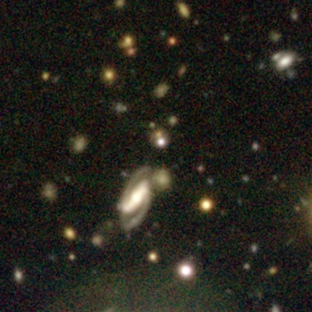

**WISE**

**W1/2/3**

**SDSS**

***gri***

**HSC**

***GRI***

**2’**

Figure 4: The IR and optical imaging of J2323-0100, an archetype of the “Extremely Red Quasars” (ERQs) at *z* 2*.*5 and a *JWST* target. Shown are WISE *(left)*, where the quasar booms out as indicated by the arrow; the SDSS image *(middle left)* with zoom-in *(middle right)* on the optically faint source, and new HSC imaging *(right)*, which shows tantalizing evidence for a faint companion

galaxy. Optical rest-frame spectra of J2323-0100, revealed very broad (FWHM = 2500-5000 km s*−*1), strongly blue-shifted (by up to

*≈*

1500 km s*−*1) [O III] *λ* 5007Å emission lines in the ERQs. This is suggestive of active outflows and potentially evidence for AGN

feedback in action at the height of SMBH activity.

**WP5: OBSERVATIONS OF QUASARS BY THE JAMES WEBB SPACE TELESCOPE**

In Ross et al. (2015) I discovered a new class of object, the “extremely red quasars”, that have optical spec- troscopy from SDSS/BOSS, and *r* [22*µ*m] *>* 14 colors (i.e., *Fν,*MIR*/Fν,*opt ;2 1000) from the Wide-field Infrared Survey Explorer (WISE; [17]) satellite, see Figure 4. The ERQs are a unique obscured quasar pop- ulation with extreme physical conditions related to powerful outflows across the line-forming regions. These sources are the signposts of the most dramatic form of quasar feedback at the peak epoch of galaxy formation, and may represent an active “blow-out” phase of quasar evolution ([18], [19]). However, due to the current lack of access to mid-infrared spectroscopy, it is still unknown whether the large IR luminosities observed in these quasars is from star formation, which would produce strong polycyclic aromatic hydrocarbon (PAH) spectral features, or, if it is from the hot dust near the central quasar, which should produce much weaker/no PAH emission.

*−*

What are the star-formation properties of luminous quasars at the peak of quasar activity? We aim to answer this by looking for the presence of polycyclic aromatic hydrocarbon (PAH) spectral features in infrared bright quasars with the *James Webb Space Telescope* (JWST).

**WP5 is high risk, high-reward.** This is an ideal investigation for the JWST, but we classify this as high-risk since we have to apply for the telescope time and are not guaranteed the data. We note this will be the single WP NPR would lead and does not impact in any direct way the other WPs. This would lead to very-high gain science. **Key Deliverables:** State-of-the-art data products from the JWST, with the observational evidence and physical interpretation of how “quasar feedback” regulates galaxy formation in high-redshift quasars.

**WP5 is medium-to-high risk, high-reward.** This is an ideal investigation for the James Webb Space Tele- scope, but we classify this as ‘high-risk’ since this is the one telescope/survey/mission where we would have to bid/apply for the telescope time and are not guaranteed the data. We mitigate the risk here by saying that this will be the one project the P.I. (NPR) would directly lead, and would lead to very-high gain science, but does not impact in any direct way any of the other WPs.

**WP6: NEW OBJECT DISCOVERY:**

The LSST will scan the sky repeatedly, enabling it, and us, to both discover new, distant transient events and to study variable objects throughout our universe. The LSST will extend our view of the changeable universe a thousand times over current surveys. The most interesting science to come may well be the discovery of new classes of objects.

**WP6 is medium-risk, exceptionally high-reward.** We class this as medium-risk, since it is tricky to class a WP with essentially unknown discovery potential as fully ‘low-risk’. However, we do not classify this as ‘high-risk’ since if there was a paucity of discovery of novel classes of objects, this would be the first time in the hitorsy of observational astrophysics that a new facility such as LSST has come online and found nothing new. **Key Deliverables:** Potential discovery of new classes of astronomical objects.

## Feasibility

By its inherent nature, our programme is high-risk and high-reward, but we *fundamentally* have the personnel and skill sets that are necessary to make this project feasible. The P.I. has a track-record of managing scientific groups in large international and world-leading collaborations. *Critically, he also has a track record of devel- oping key software packages on strict deadlines, e.g. the BOSS Quasar Target Selection software package (that contained a suite of novel ML algorithms).*

# Resources (including project costs)

Here we summarize and justify the budget.

**TEAM COMPOSITION:** Our team will consist of the P.I, three postdoctoral research associates (PDRAs), and 1 PhD student. Two postdoctoral appointments will be for three years each and one will be for a four year appointment (a total of 10 FTE over 5 years). The PhD student will have a four year appointment. The ambitious nature of this project requires a large team of both observational and theoretical postdoctoral scholars and a PhD student to complete the proposed research. The P.I. is not a current member of academic staff and therefore has no responsibilities extending beyond research. As such, the P.I. is charged at 100% and, if successful, will focus solely on the aims of the project. Again, this will be necessary to achieve all our goals on the given schedule.

**SALARIES:** The primary expenditure of our project corresponds to salaries in order support the large team necessary for this project. The P.I will be fully involved (project management, scientific analysis, student supervision, postdoc mentorship, proposal writing, communication with external collaborations, and paper writing) and is covered at the 100% level over 5 years. Salaries are determined according to the UoE salary scale: e80.7k per FTE for the P.I, e61.3k per FTE for the PDRAs and e21.1k per FTE for PhD students. The total cost of salaries over 5 years is e**1106k**.

**TRAVEL:** A major expense is in the form of travel. I expect all group members to disseminate our results in international conference but also to participate in external collaboration meeting (at least one per year). Due to the nature and timing of our proposal, it will almost certainly be critical for the PDRAs to have extended (several week long) visits to the US and ESO Chile. I have allocated thus allocated e10k/year for all members

|  |  |  |  |  |
| --- | --- | --- | --- | --- |
| **Cost Category** | | | **Total in Euro** | |
| **Direct Costs** | **Personnel** | PI | 403,854 | |
| Senior Staff |  | |
| Postdocs | 617,145 | |
| Students | 84,545 | |
| Other |  | |
| *i. Total Direct Costs for Personnel (in Euro)* | | 1,105,544 | |
| **Travel** | | 190,000 | |
| **Equipment** | | 53,000 | |
| **Other goods and services** | Consumables | 0 | |
| Publications (including Open Access fees), etc. | 15,000 | |
| Other, incl. SDSS-IV Project buy-in, DESI Project buy-in, Audit, Recruitment, Publication. | 413,535 | |
| *ii. Total Other Direct Costs (in Euro)* | | 656,536 | |
| **A – Total Direct Costs (i + ii)** (in Euro) | | | 1,762,080 | |
| **B – Indirect Costs (overheads)** 25% of Direct Costs (in Euro) | | | 262,457 | |
| **C1 – Subcontracting Costs** (no overheads) (in Euro) | | | 15,000 | |
| **C2 – Other Direct Costs with no overheads** (in Euro) | | | 0 | |
| **Total Estimated Eligible Costs (A + B + C)** (in Euro) | | | 2,217,600 | |
| **Total Requested EU Contribution** (in Euro)6 | | | 2,217,600 | |
| **For the above cost table, please indicate the duration of the project in months:** | | | | 60 |
| **For the above cost table, please indicate the % of working time the PI dedicates to the project over the period of the grant:** | | | | **100%** |

The P.I. will spend 100% of their time on the project, which will include achieving the science objectives, managing and supervising personal, as well as the associated logistical overhead time commitments.

of the group for travel. This level of commitment is necessary as has been proved by the P.I.’s recent and continued involvement with the e.g. US-based surveys (and the benefit to his research fellowship). The total travel budget is e**190k.**

**PUBLICATIONS:** Our work will be published in international journals such as Nature, Nature Astronomy, Science, Monthly Notices of the Royal Astronomical Society and the Astrophysical Journal. I have allocated e3k/year for the cost of publications. In addition, all papers will be on the arXiv preprint server free of charge. The total publications budget is e**15k.**

**EQUIPMENT & CONSUMABLES:** I have allocated e10k/person for the initial purchase of a desktop and lap- top computer. Consumables are limited to e600/year (for the purchase of back-up drives and other equipment). The total equipment and consumables budget is e**53k.**

**ACCESS TO LARGE FACILITIES:** We ask for additional funds that are available to cover “access to large facilities”. We request support for the “buy-in” to two of the new surveys, SDSS-V and DESI, the costs are e184.1k and e200.1krespectively . We specifically request access to these funds as it gives our project access to telescopes and data in the North and Southern Hemispheres (for complete coverage of the celestial sphere) and delivers the crucial early spectroscopy that will be vital to train, test and build our data science and machine learning codes and algorithms. We emphasise that the science return is ‘exponential’ (rather than ‘linearly’) dependent on the breadth of data available and heralds a brand new regime of “several- survey” or “multi-mission” astronomy. Buy-in allows the two observational PDRAs along with the PhD student to have data access rights here and *would place the P.I. and the University of Edinburgh as the only group and institute in the world to be involved in SDSS-V, DESI, 4MOST, LSST and ESA Euclid and JWST*. The total budget for the access to large facilites is e**384.2k**.

Total budget before facilities costs: e**this amount**.

Total budget including facilities costs: e**this amount+384.2k**.

# References

D. M. Alexander and R. C. Hickox. What drives the growth of black holes? *New A.R.*, 56:93–121, June 2012. doi: 10.1016/j.newar.2011.11.003.

D. Anglés-Alcázar, F. Özel, and R. Davé. Black Hole-Galaxy Correlations without Self-regulation. *ApJ*, 770: 5, June 2013. doi: 10.1088/0004-637X/770/1/5.

D. Anglés-Alcázar, F. Özel, R. Davé, N. Katz, J. A. Kollmeier, and B. D. Oppenheimer. Torque-limited Growth of Massive Black Holes in Galaxies across Cosmic Time. *ApJ*, 800:127, Feb 2015. doi: 10.1088/ 0004-637X/800/2/127.

D. Anglés-Alcázar, C.-A. Faucher-Giguère, E. Quataert, P. F. Hopkins, R. Feldmann, P. Torrey, A. Wetzel, and D. Kereš. Black holes on FIRE: stellar feedback limits early feeding of galactic nuclei. *MNRAS*, 472: L109–L114, Nov 2017. doi: 10.1093/mnrasl/slx161.

R. Bieri, Y. Dubois, J. Rosdahl, A. Wagner, J. Silk, and G. A. Mamon. Outflows driven by quasars in high- redshift galaxies with radiation hydrodynamics. *MNRAS*, 464:1854–1873, Jan 2017. doi: 10.1093/mnras/ stw2380.

H. Bondi. On spherically symmetrical accretion. *MNRAS*, 112:195, 1952. doi: 10.1093/mnras/112.2.195.

H. Bondi and F. Hoyle. On the mechanism of accretion by stars. *MNRAS*, 104:273, 1944. doi: 10.1093/mnras/ 104.5.273.

C. M. Booth and J. Schaye. Cosmological simulations of the growth of supermassive black holes and feedback from active galactic nuclei: method and tests. *MNRAS*, 398:53–74, Sept 2009. doi: 10.1111/j.1365-2966. 2009.15043.x.

1. Cielo, V. Antonuccio-Delogu, A. V. Macciò, A. D. Romeo, and J. Silk. 3D simulations of the early stages of AGN jets: geometry, thermodynamics and backflow. *MNRAS*, 439:2903–2916, Apr 2014. doi: 10.1093/ mnras/stu161.
2. Costa, D. Sijacki, and M. G. Haehnelt. Feedback from active galactic nuclei: energy- versus momentum- driving. *MNRAS*, 444:2355–2376, Nov 2014. doi: 10.1093/mnras/stu1632.

R. A. Crain et al. The EAGLE simulations of galaxy formation: calibration of subgrid physics and model variations. *MNRAS*, 450:1937–1961, June 2015. doi: 10.1093/mnras/stv725.

M. Curtis and D. Sijacki. Resolving flows around black holes: numerical technique and applications. *MNRAS*, 454:3445–3463, Dec 2015. doi: 10.1093/mnras/stv2246.

M. Curtis and D. Sijacki. Powerful quasar outflow in a massive disc galaxy at *z* 5. *MNRAS*, 457:L34–L38, March 2016a. doi: 10.1093/mnrasl/slv199.

*∼*

M. Curtis and D. Sijacki. Resolving flows around black holes: the impact of gas angular momentum. *MNRAS*, 463:63–77, Nov 2016b. doi: 10.1093/mnras/stw1944.

R. Davé, R. Thompson, and P. F. Hopkins. MUFASA: galaxy formation simulations with meshless hydrody- namics. *MNRAS*, 462:3265–3284, Nov 2016. doi: 10.1093/mnras/stw1862.

R. Edgar. A review of Bondi-Hoyle-Lyttleton accretion. *New A.R.*, 48:843–859, Sept 2004. doi: 10.1016/j. newar.2004.06.001.

M. Elvis et al. Atlas of quasar energy distributions. *ApJS*, 95:1–68, Nov 1994. doi: 10.1086/192093.

E. Emsellem, F. Renaud, F. Bournaud, B. Elmegreen, F. Combes, and J. M. Gabor. The interplay between a galactic bar and a supermassive black hole: nuclear fuelling in a subparsec resolution galaxy simulation. *MNRAS*, 446:2468–2482, Jan 2015. doi: 10.1093/mnras/stu2209.

A. C. Fabian. Observational Evidence of Active Galactic Nuclei Feedback. *ARA&A*, 50:455–489, Sept 2012. doi: 10.1146/annurev-astro-081811-125521.

V. Gaibler, S. Khochfar, M. Krause, and J. Silk. Jet-induced star formation in gas-rich galaxies. *MNRAS*, 425: 438–449, Sept 2012. doi: 10.1111/j.1365-2966.2012.21479.x.

M. Gaspari, M. Ruszkowski, and S. P. Oh. Chaotic cold accretion on to black holes. *MNRAS*, 432:3401–3422, July 2013. doi: 10.1093/mnras/stt692.

J. E. Greene, C. Y. Peng, M. Kim, C.-Y. Kuo, J. A. Braatz, C. M. V. Impellizzeri, J. J. Condon, K. Y. Lo,

C. Henkel, and M. J. Reid. Precise Black Hole Masses from Megamaser Disks: Black Hole-Bulge Relations

at Low Mass. *ApJ*, 721:26–45, Sept 2010. doi: 10.1088/0004-637X/721/1/26.

F. Haardt, V. Gorini, U. Moschella, A. Treves, and M. Colpi, editors. *Astrophysical Black Holes*, volume 905 of *Lecture Notes in Physics, Berlin Springer Verlag*, 2016. doi: 10.1007/978-3-319-19416-5.

N. Häring and H.-W. Rix. On the Black Hole Mass-Bulge Mass Relation. *ApJ Lett.*, 604:L89–L92, Apr 2004. doi: 10.1086/383567.

T. Heckman and P. Best. The Co-Evolution of Galaxies and Supermassive Black Holes: Insights from Surveys of the Contemporary Universe. *ArXiv:1403.4620v1*, March 2014.

P. F. Hopkins and E. Quataert. How do massive black holes get their gas? *MNRAS*, 407:1529–1564, Sept 2010. doi: 10.1111/j.1365-2966.2010.17064.x.

P. F. Hopkins and E. Quataert. An analytic model of angular momentum transport by gravitational torques: from galaxies to massive black holes. *MNRAS*, 415:1027–1050, Aug 2011. doi: 10.1111/j.1365-2966.2011. 18542.x.

P. F. Hopkins, L. Hernquist, T. J. Cox, and D. Kereš. A Cosmological Framework for the Co-Evolution of Quasars, Supermassive Black Holes, and Elliptical Galaxies. I. Galaxy Mergers and Quasar Activity. *ApJS*, 175:356–389, Apr 2008. doi: 10.1086/524362.

P. F. Hopkins, P. Torrey, C.-A. Faucher-Giguère, E. Quataert, and N. Murray. Stellar and quasar feedback in concert: effects on AGN accretion, obscuration, and outflows. *MNRAS*, 458:816–831, May 2016. doi: 10.1093/mnras/stw289.

P. F Hopkins et al. FIRE-2 Simulations: Physics versus Numerics in Galaxy Formation. *ArXiv e-prints*, Feb 2017.

F. Hoyle and R. A. Lyttleton. The effect of interstellar matter on climatic variation. *Proceedings of the* *Cambridge Philosophical Society*, 35:405, 1939. doi: 10.1017/S0305004100021150.

M. Huarte-Espinosa, M. Krause, and P. Alexander. 3D magnetohydrodynamic simulations of the evolution of magnetic fields in Fanaroff-Riley class II radio sources. *MNRAS*, 417:382–399, Oct 2011. doi: 10.1111/j. 1365-2966.2011.19271.x.

A. King and K. Pounds. Powerful Outflows and Feedback from Active Galactic Nuclei. *ARA&A*, 53:115–154, Aug 2015. doi: 10.1146/annurev-astro-082214-122316.

A. Koratkar and O. Blaes. The Ultraviolet and Optical Continuum Emission in Active Galactic Nuclei: The Status of Accretion Disks. *PASP*, 111:1–30, Jan 1999. doi: 10.1086/316294.

J. Kormendy and L. C. Ho. Coevolution (Or Not) of Supermassive Black Holes and Host Galaxies. *ARA&A*, 51:511–653, Aug 2013. doi: 10.1146/annurev-astro-082708-101811.

S. M. LaMassa, S. Cales, E. C. Moran, A. D. Myers, G. T. Richards, M. Eracleous, T. M. Heckman, L. Gallo, and C. M. Urry. The Discovery of the First “Changing Look” Quasar: New Insights Into the Physics and Phenomenology of Active Galactic Nucleus. *ApJ*, 800:144, Feb 2015. doi: 10.1088/0004-637X/800/2/144.

A. Lawrence. The UV peak in active galactic nuclei: a false continuum from blurred reflection? *MNRAS*, 423: 451–463, June 2012. doi: 10.1111/j.1365-2966.2012.20889.x.

1. Lawrence. Clues to the Structure of AGN Through Massive Variability Surveys. In A. Mickaelian,
   1. Lawrence, and T. Magakian, editors, *Astronomical Surveys and Big Data*, volume 505 of *Astronomi-* *cal Society of the Pacific Conference Series*, page 107, June 2016.

A. Lawrence. Quasar viscosity crisis. *Nature Astronomy*, 2:102âA˘ S¸ 103, Jan 2018.

C. L. MacLeod, N. P. Ross, et al. A systematic search for changing-look quasars in SDSS. *MNRAS*, 457: 389–404, March 2016. doi: 10.1093/mnras/stv2997.

C. L. MacLeod et al. Modeling the Time Variability of SDSS Stripe 82 Quasars as a Damped Random Walk.

*ApJ*, 721:1014–1033, Oct 2010. doi: 10.1088/0004-637X/721/2/1014.

R. J. McLure and J. S. Dunlop. On the black hole-bulge mass relation in active and inactive galaxies. *MNRAS*, 331:795–804, Apr 2002. doi: 10.1046/j.1365-8711.2002.05236.x.

A. M. Meisner, B. C. Bromley, P. E. Nugent, D. J. Schlegel, S. J. Kenyon, E. F. Schlafly, and K. S. Dawson. Searching for Planet Nine with Coadded WISE and NEOWISE-Reactivation Images. *AJ*, 153:65, Feb 2017a. doi: 10.3847/1538-3881/153/2/65.

A. M. Meisner, D. Lang, and D. J. Schlegel. Deep Full-sky Coadds from Three Years of WISE and NEOWISE

Observations. *AJ*, 154:161, Oct 2017b. doi: 10.3847/1538-3881/aa894e.

A. Merloni, P. Predehl, W. Becker, H. Böhringer, T. Boller, H. Brunner, M. Brusa, K. Dennerl, M. Freyberg,

P. Friedrich, A. Georgakakis, F. Haberl, G. Hasinger, N. Meidinger, J. Mohr, K. Nandra, A. Rau, T. H. Reiprich, J. Robrade, M. Salvato, A. Santangelo, M. Sasaki, A. Schwope, J. Wilms, and t. German eROSITA Consortium. eROSITA Science Book: Mapping the Structure of the Energetic Universe. *ArXiv e-prints*, Sept 2012.

C. W. Morgan, C. S. Kochanek, N. D. Morgan, and E. E. Falco. The Quasar Accretion Disk Size-Black Hole Mass Relation. *ApJ*, 712:1129–1136, Apr 2010. doi: 10.1088/0004-637X/712/2/1129.

C. W. Morgan et al. Further Evidence that Quasar X-Ray Emitting Regions are Compact: X-Ray and Optical Microlensing in the Lensed Quasar Q J0158-4325. *ApJ*, 756:52, Sept 2012. doi: 10.1088/0004-637X/756/ 1/52.

A. M. Mosquera and C. S. Kochanek. The Microlensing Properties of a Sample of 87 Lensed Quasars. *ApJ*, 738:96, Sept 2011. doi: 10.1088/0004-637X/738/1/96.

T. Naab and J. P. Ostriker. Theoretical Challenges in Galaxy Formation. *ARA&A*, 55:59–109, Aug 2017. doi: 10.1146/annurev-astro-081913-040019.

H. Netzer. Revisiting the Unified Model of Active Galactic Nuclei. *ARA&A*, 53:365, 2015.

P. Padovani, D. M. Alexander, R. J. Assef, B. De Marco, P. Giommi, R. C. Hickox, G. T. Richards, V. Smolcˇic´,

E. Hatziminaoglou, V. Mainieri, and M. Salvato. Active galactic nuclei: what’s in a name? *A&ARv*, 25:2, Aug 2017. doi: 10.1007/s00159-017-0102-9.

A. Pillepich et al. Simulating galaxy formation with the IllustrisTNG model. *MNRAS*, 473:4077–4106, Jan 2018. doi: 10.1093/mnras/stx2656.

D. Pooley, J. A. Blackburne, S. Rappaport, and P. L. Schechter. X-Ray and Optical Flux Ratio Anomalies in Quadruply Lensed Quasars. I. Zooming in on Quasar Emission Regions. *ApJ*, 661:19–29, May 2007. doi: 10.1086/512115.

J. E. Pringle. Accretion discs in astrophysics. *ARA&A*, 19:137–162, 1981. doi: 10.1146/annurev.aa.19.090181. 001033.

G. T. Richards et al. Spectral Energy Distributions and Multiwavelength Selection of Type 1 Quasars. *ApJS*, 166:470–497, Oct 2006. doi: 10.1086/506525.

G. Risaliti and E. Lusso. A Hubble Diagram for Quasars. *ApJ*, 815:33, Dec 2015. doi: 10.1088/0004-637X/ 815/1/33.

O. Roos, S. Juneau, F. Bournaud, and J. M. Gabor. Thermal and Radiative Active Galactic Nucleus Feedback have a Limited Impact on Star Formation in High-redshift Galaxies. *ApJ*, 800:19, Feb 2015. doi: 10.1088/ 0004-637X/800/1/19.

Y. M. Rosas-Guevara, R. G. Bower, J. Schaye, M. Furlong, C. S. Frenk, C. M. Booth, R. A. Crain, C. Dalla Vecchia, M. Schaller, and T. Theuns. The impact of angular momentum on black hole accretion rates in simulations of galaxy formation. *MNRAS*, 454:1038–1057, Nov 2015. doi: 10.1093/mnras/stv2056.

N. P. Ross et al. The SDSS-III Baryon Oscillation Spectroscopic Survey: Quasar Luminosity Function from Data Release Nine. *ApJ*, 773:14, Aug 2013. doi: 10.1088/0004-637X/773/1/14.

N. P. Ross et al. Extremely red quasars from SDSS, BOSS and WISE: classification of optical spectra. *MNRAS*, 453:3932–3952, Nov 2015. doi: 10.1093/mnras/stv1710.

N. P. Ross et al. A new physical interpretation of optical and infrared variability in quasars. *Nature Astronomy*, 2018.

J. J. Ruan, S. F. Anderson, S. L. Cales, M. Eracleous, P. J. Green, E. Morganson, J. C. Runnoe, Y. Shen,

T. D. Wilkinson, M. R. Blanton, T. Dwelly, A. Georgakakis, J. E. Greene, S. M. LaMassa, A. Merloni, and

D. P. Schneider. Toward an Understanding of Changing-look Quasars: An Archival Spectroscopic Search in SDSS. *ApJ*, 826:188, Aug 2016. doi: 10.3847/0004-637X/826/2/188.

J. N. Runco et al. Broad H*β* Emission-line Variability in a Sample of 102 Local Active Galaxies. *ApJ*, 821:

33, Apr 2016. doi: 10.3847/0004-637X/821/1/33.

J. C. Runnoe, S. Cales, J. J. Ruan, M. Eracleous, S. F. Anderson, Y. Shen, P. J. Green, E. Morganson,

S. LaMassa, J. E. Greene, T. Dwelly, D. P. Schneider, A. Merloni, A. Georgakakis, and A. Roman-Lopes.

Now you see it, now you don’t: the disappearing central engine of the quasar J1011+5442. *MNRAS*, 455: 1691–1701, Jan 2016. doi: 10.1093/mnras/stv2385.

S. Salviander, G. A. Shields, K. Gebhardt, and E. W. Bonning. The Black Hole Mass-Galaxy Bulge Rela- tionship for QSOs in the Sloan Digital Sky Survey Data Release 3. *ApJ*, 662:131–144, June 2007. doi: 10.1086/513086.

J. Schaye et al. The EAGLE project: simulating the evolution and assembly of galaxies and their environments.

*MNRAS*, 446:521–554, Jan 2015. doi: 10.1093/mnras/stu2058.

N. I. Shakura and R. A. Sunyaev. Black holes in binary systems. Observational appearance. *Astron. & Astro-* *phys.*, 24:337, 1973.

1. Sijacki, V. Springel, T. Di Matteo, and L. Hernquist. A unified model for AGN feedback in cosmological simulations of structure formation. *MNRAS*, 380:877–900, Sept 2007. doi: 10.1111/j.1365-2966.2007. 12153.x.
2. Sirko and J. Goodman. Spectral energy distributions of marginally self-gravitating quasi-stellar object discs.

*MNRAS*, 341:501–508, May 2003. doi: 10.1046/j.1365-8711.2003.06431.x.

M. Vogelsberger, S. Genel, D. Sijacki, P. Torrey, V. Springel, and L. Hernquist. A model for cosmological simulations of galaxy formation physics. *MNRAS*, 436:3031–3067, Dec 2013. doi: 10.1093/mnras/stt1789.

M. Vogelsberger, S. Genel, V. Springel, P. Torrey, D. Sijacki, D. Xu, G. Snyder, D. Nelson, and L. Hernquist. Introducing the Illustris Project: simulating the coevolution of dark and visible matter in the Universe. *MNRAS*, 444:1518–1547, Oct 2014. doi: 10.1093/mnras/stu1536.

R. Weinberger et al. Simulating galaxy formation with black hole driven thermal and kinetic feedback. *MNRAS*, 465:3291–3308, March 2017. doi: 10.1093/mnras/stw2944.

A. R. Wetzel, P. F. Hopkins, J.-h. Kim, C.-A. Faucher-Giguère, D. Kereš, and E. Quataert. Reconciling Dwarf Galaxies with ΛCDM Cosmology: Simulating a Realistic Population of Satellites around a Milky Way-mass Galaxy. *ApJ Lett.*, 827:L23, Aug 2016. doi: 10.3847/2041-8205/827/2/L23.

Q. Yang et al. Discovery of 21 New Changing-look AGNs in Northern Sky. *ArXiv e-prints*, Nov 2017.

F. Yuan and R. Narayan. Hot Accretion Flows Around Black Holes. *ARA&A*, 52:529–588, Aug 2014. doi: 10.1146/annurev-astro-082812-141003.